Here, let’s try to compose some questions for Miguel when we talk to him (hopefully next week). So over the weekend, let’s compose some questions.

1. Feature questions:
   1. What does STIM mean (Job op code)? → stimulation, fracturing
   2. Like kind group (OCM - MECHANICAL ISOLATION, OCM - PP PUC) → categorize by suffix, PP PUC - completion technique (poking holes), Mechanical Isolation - subtype, additional context to compare but
      1. First use primary job type to analyze
         1. Initial completion - brand new well, now want to drill well
         2. Recompletion - back into same well, same fracturing process (additional oil or repairing broken well)
            1. Maybe look at production after recompletion, does pumping proponents require more maintenance?
   3. Start date vs. job phase actual start date vs stim int start date → job phase - start of the entire completion, stim int - intervals unique start/end date, might have multiple op dates bc of a pause; don’t need job dates
   4. Rig accept

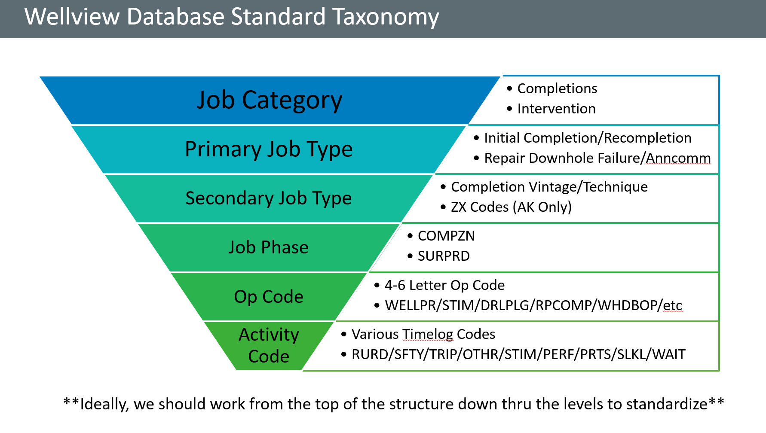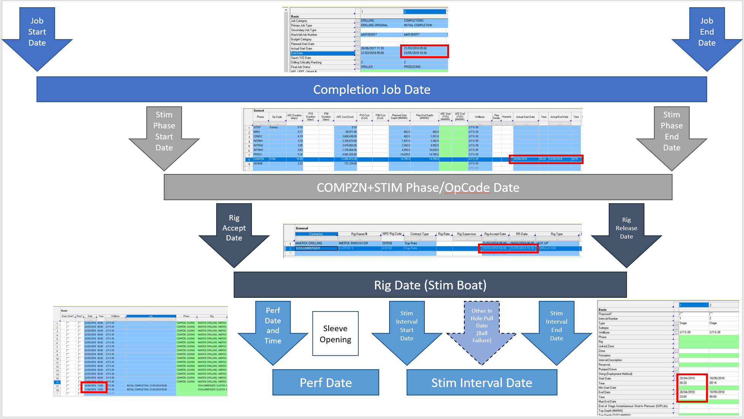

1. For the first 3 files, (cross_bu_dnc_stim_stage_detail, gcbu_dnc_recompletions, gcbu_dnc_stim_stage) what is the difference between them? They all seem to have relatively the same features.
   1. Should be a table with a time log
2. What is the difference between the second and third file? What’s the difference between recompletions and stim stages?
   1. In the name
3. Given how the missing values worked out for the first spreadsheet how would you recommend cleaning them?
   1. Will hold off until he gets back with the tables possibly shifted
4. We see 4 different features that talk about companies (STIM_Company, STIM_Diversion_Company, STIM Treat Company, and Diversion Company) some Company Ids overlapping throughout the 4, but others don’t, which ones should we be focusing on?
   1. Focus on rig contractor
5. How do the production numbers relate to the different wells? In that, should we take into consideration the well kind when looking at production?
   1. More production does not mean better job, more money always means more oil, not always in a certain area (not full story), keep regions in mind, more normalized, not an essential factor, crew’s efficiency is independent from production, ex: more production = more maintenance

